***Wizard Needs Matches!***

By Canadingeers

Introduction Letter:

Greetings my annoying, babbling, clumsy, dim-witted, elephantine, fool-hardy, worthless apprentice (whoever or whatever you are), know that I, the Most Exalted and Esteemed High Wizard Pomp Aus, the Advisor of Visors, the Writer of the Book of Wrongs, the Stander of Lying Lions (Thrice cursed be their slothful dishonesty), the Puncher of Fruit, the Latter Former of the Order of the Ladder, the Flier of Fire, the Burier of Straws, the Dragging Dragon Champion of the Year (for 42 years running), the Savior of Savory Thyme (the Sacred Spice of which all Life flows), the Inventor of the Lightened Knight Armor (“No need to wait for the weight-saving benefits and night vision my armor provides, order yours today!), Winner of Most Humble Wizard of the Century (for the fourth century running) have run out of matches.

Know that I, the Most Exalted and Esteemed High Wizard Pomp Aus, the Advisor of Visors, the Writer of the Book of Wrongs, the Stander of Lying Lions (Thrice cursed be their slothful dishonesty), the Puncher of Fruit, the Latter Former of the Order of the Ladder, the Flier of Fire, the Burier of Straws, the Dragging Dragon Champion of the Year (for 42 years running), the Savior of Savory Thyme (the Sacred Spice of which all Life flows), the Inventor of the Lightened Knight Armor (“No need to wait for the weight-saving benefits and night vision my armor provides, order yours today!), Winner of Most Humble Wizard of the Century (for the fourth century running) cannot be using mundane matches, oh no. I must have the cream of the crop, the Fabled Matches of Don Geon, their Infernal Highness!

Therefore, know that I, the Most Exalted and Esteemed High Wizard Pomp Aus, the Advisor of Visors, the Writer of the Book of Wrongs, the Stander of Lying Lions (Thrice cursed be their slothful dishonesty), the Puncher of Fruit, the Latter Former of the Order of the Ladder, the Flier of Fire, the Burier of Straws, the Dragging Dragon Champion of the Year (for 42 years running), the Savior of Savory Thyme (the Sacred Spice of which all Life flows), the Inventor of the Lightened Knight Armor (“No need to wait for the weight-saving benefits and night vision my armor provides, order yours today!), Winner of Most Humble Wizard of the Century (for the fourth century running), have sent you, my annoying, babbling, clumsy, dim-witted, elephantine, fool-hardy, worthless apprentice (whoever or whatever you are) to the Looping Infinite Dungeon of Don Geon’s Infinite Dungeon of Looping for you, my annoying, babbling, clumsy, dim-witted, elephantine, fool-hardy, worthless apprentice (whoever or whatever you are), to bring me matches!

As you, my annoying, babbling, clumsy, dim-witted, elephantine, fool-hardy, worthless apprentice (whoever or whatever you are), cannot hope to match the brilliance of myself, the Most Exalted and Esteemed High Wizard Pomp Aus, the Advisor of Visors, the Writer of the Book of Wrongs, the Stander of Lying Lions (Thrice cursed be their slothful dishonesty), the Puncher of Fruit, the Latter Former of the Order of the Ladder, the Flier of Fire, the Burier of Straws, the Dragging Dragon Champion of the Year (for 42 years running), the Savior of Savory Thyme (the Sacred Spice of which all Life flows), the Inventor of the Lightened Knight Armor (“No need to wait for the weight-saving benefits and night vision my armor provides, order yours today!), Winner of Most Humble Wizard of the Century (for the fourth century running), I have prepared this Tome of Tombs to extend my investment in you, my annoying, babbling, clumsy, dim-witted, elephantine, fool-hardy, worthless apprentice (whoever or whatever you are).

Hugs and Kisses,

Your Master,

The Most Exalted and Esteemed High Wizard Pomp Aus, the Advisor of Visors, the Writer of the Book of Wrongs, the Stander of Lying Lions (Thrice cursed be their slothful dishonesty), the Puncher of Fruit, the Latter Former of the Order of the Ladder, the Flier of Fire, the Burier of Straws, the Dragging Dragon Champion of the Year (for 42 years running), the Savior of Savory Thyme (the Sacred Spice of which all Life flows), the Inventor of the Lightened Knight Armor (“No need to wait for the weight-saving benefits and night vision my armor provides, order yours today!), Winner of Most Humble Wizard of the Century (for the fourth century running).

XOXOXOXs

Installing Wizard Needs Matches!:

Download the .exe and data folder to a location on computer.

Remember this location.

Starting the Game:

Navigate to the WizardNeedsMatches.exe (where you saved it during installation. You do remember where, correct?)

Run the .exe.

Tweak settings.

Hit Play!

Choose from the Menu.

Playing the Game:

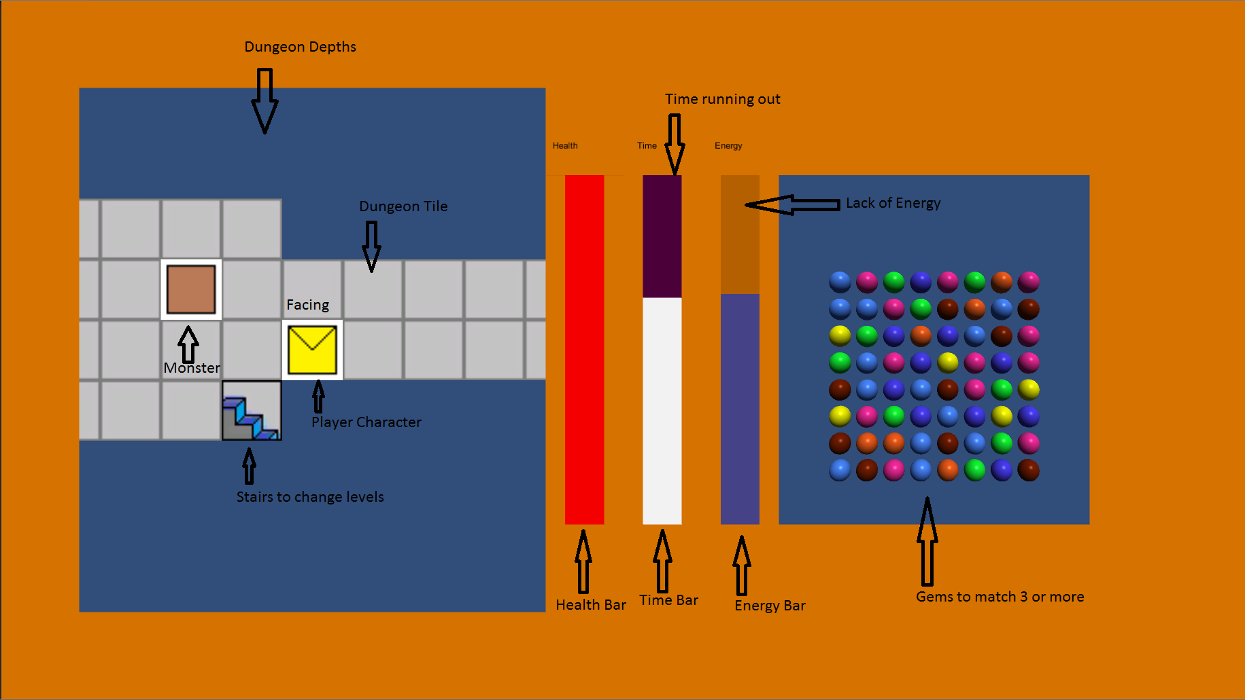

Starting:

Click the Start Game Button.

Once the game has finished loading, hit Enter on every level to start the game.

Moving/Casting:

The monsters assume from your slack-jawed drooling that you are dead. They only move after you have shown signs of life. Due to your clumsiness, I’d guess you can only stay perfectly still for a mere fifteen seconds. Good luck surviving. Your time is shown by the white Bar. (And matching jewels will help still your quaking body…)

Move your pathetic self about the dungeon with the Arrow keys… or “Wasding” as you young folks call it. Rotate with Q and E.

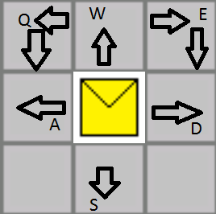

Stairs go deeper into new levels.

Cast your not-as-great-as-mine spells by shouting “One” through “Four.” Yes, yes, or hit the number keys on your “keybored.”

Spells:

1: Mana bolt: Moderate Damage.

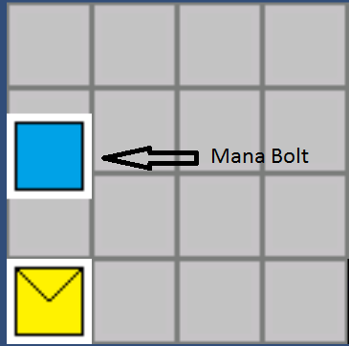

2: Fire bolt: Weak Damage. Lights tiles on fire.

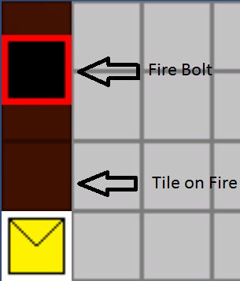

3: Ice bolt: Weak Damage. Covers tiles with ice, anybody can slide down them.



4: Lightning bolt: Weak Damage. Covers tiles with electricity. Slows down anybody on them.

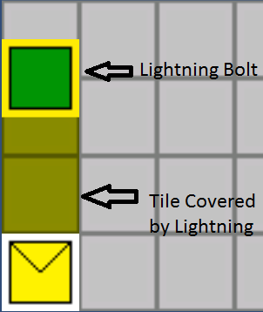

Your tiles can be changed by casting another spell on them, or they will fizzle out in a few turns.

But your spellcasting may look especially stupid if you fire your spells in the wrong direction. Use Q and E to rotate yourself, hopefully towards the thing you’re casting at, before casting your spells.

Energy: Blue bar

Running out of energy because you are frolicking around looking for daisies or casting spells?

On the right side of the screen click on two adjoining gems to swap them around to try to make at least 3 in a row of the same color in order to regain energy to move and cast spells.

The more you can match, the more time you have to match.

Physical: Health bar: red

If you want, you can try shoving your wand up a monster’s nose. This will annoy them a bit, but monsters have noses full of gooey mucus. You will have to repeatedly stick the wand up the nose to get rid of the mucus in order to reach the brain to kill them, all the while they can reach you with their weapons…

Main menu:

Hit “ESC” to go to main menu.

Closing the Game:

Running away you yellow-bellied lily-livered coward?

Fine… I’ll wait for a better apprentice.

Hit “ESC”.

Click “Exit”.

Nothing to see here…

Stop reading, this isn’t funny anymore.

What are you doing, this page is blank…

Fine, you made it here.

I did mention that the dungeon is the Looping Infinite Dungeon of Don Geon’s Infinite Dungeon of Looping, but you may not have noticed. There is no end except your death, and I will finally be rid of my loathsome apprentice, MWAHHAHAHAHAHAHAHAHAHAHA!!

Now go get me some matches!